Lab 1. Preparation tasks Template for answers

Student names and LiU-IDs: (Max 2 students per group):

1. Antonio Tällberg Ilestad (Antta839)

2. Ivar Gorenko (Ivago071)

Submission date:2021-11-10

Version (in case you need to re-submit):

1. Basic image operations and data types

1 A) What is the highest pixel value in the image?

The highest value in the image is 253

1 B) What is the maximum value for Image2?

The highest value in the image2 is 16

1 C) What do you see if you display Image2?

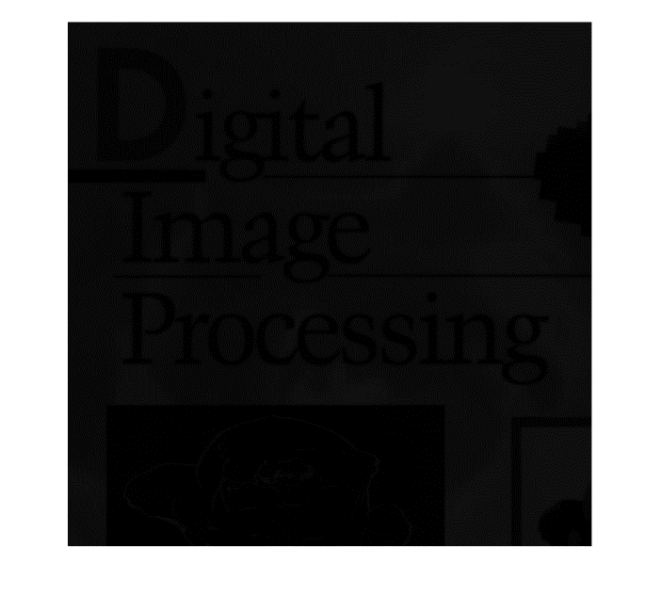

It is a very dark version of Image

1 D) Image3:

The image looks very pixelated in the light grey transitions.

1 E) How many grey levels does Image3 have?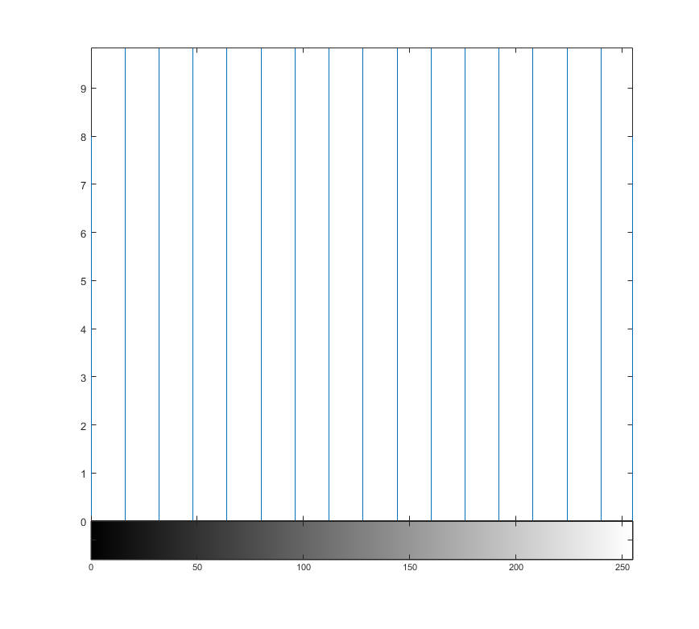

There are 16 grey levels.

1 F) Explain what has happened to the image after these operations!

After dividing with 16 we converted all pixel info between integers 0-16

effectively limiting us to 16 grey levels (0-16). After multiplying

we just stretched these 17 levels so that they were evenly divided

between values from 0-255, we see that Image2 has values 0, 16, 32, ..., 255 if we look at its matrix in matlab

1 G) Explain the difference between using uint8 images and double images in this task.

When doubles are divided, they are expressed as a fraction, so no information is being destroyed when we divide Image in double format with 16. When we divide Image in uint8 format with 16 all the fractions are converted to an integer between 0-16, so about 15/16 (around 94%) of the information is destroyed in this operation.

1 H) Which class (data type) should you make sure to use when applying such operations to images?

Should always use data type doubles so that no information is destroyed during arithmetic operations of the image data

2. Contrast stretching and image histogram

2 A) What is the max- and min- values for the image?

The max value is 0.698 and the minimum value is 0.2902

2 B) Histogram:

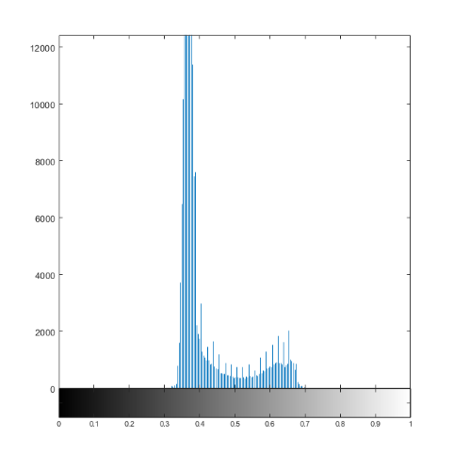

We predicted that most values would be close to 0.5 (the middle) which is the case here.

2 C) Resulting image after contrast stretching:

2 D) What will the max- and min- values be for the stretched image?

We converted the image to data type double so the minimum value is 0 and the maximum value is 1 according to the equation.

2 E) Histogram for the stretched image:

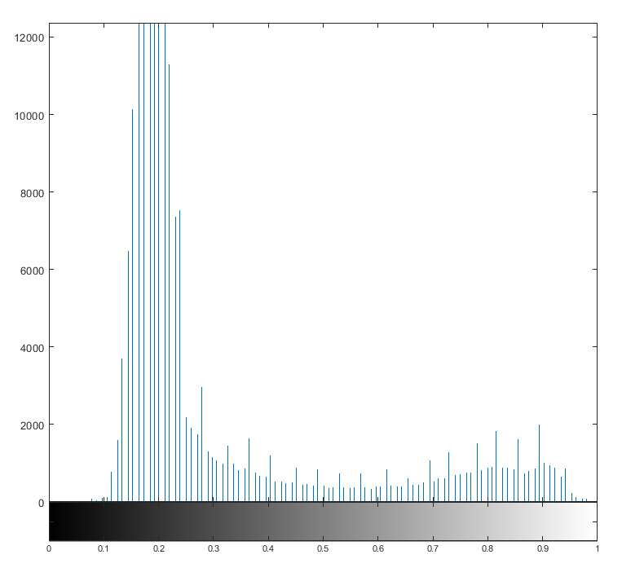

3. Image subtraction

3 A) Enhanced difference image:

4. Histogram equalization

4 A) Equalized image:

4 B) Histogram for the equalized image:

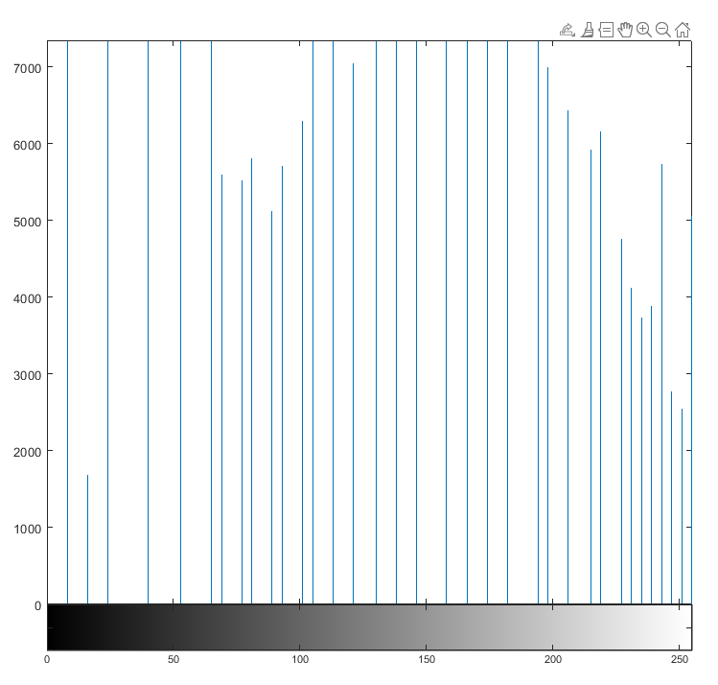

5. Image division and shading correction

5 A) Histogram image:

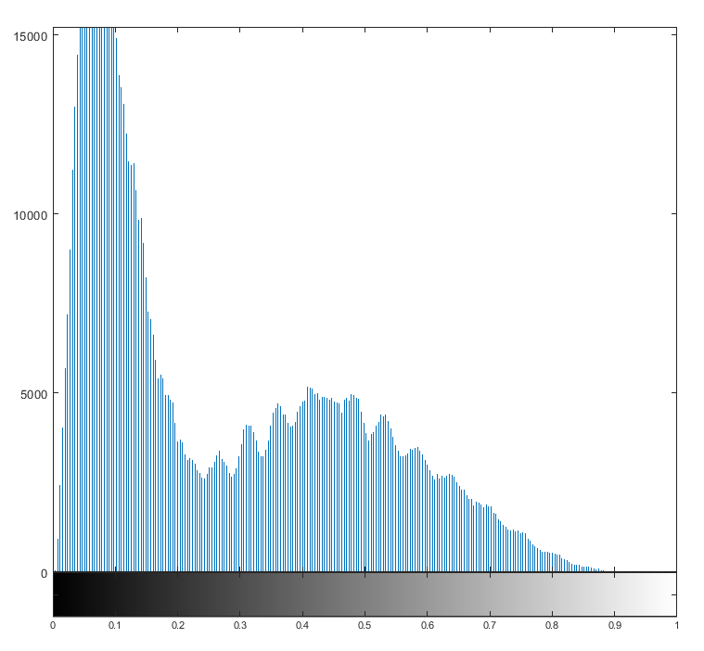

5 B) Is it possible to find a global threshold to segment this image (look at the histogram)?

Not in a good way that wouldn’t result in some sort of compromise. The values are spread out too much for a good global threshold.

5 C) Recovered image:

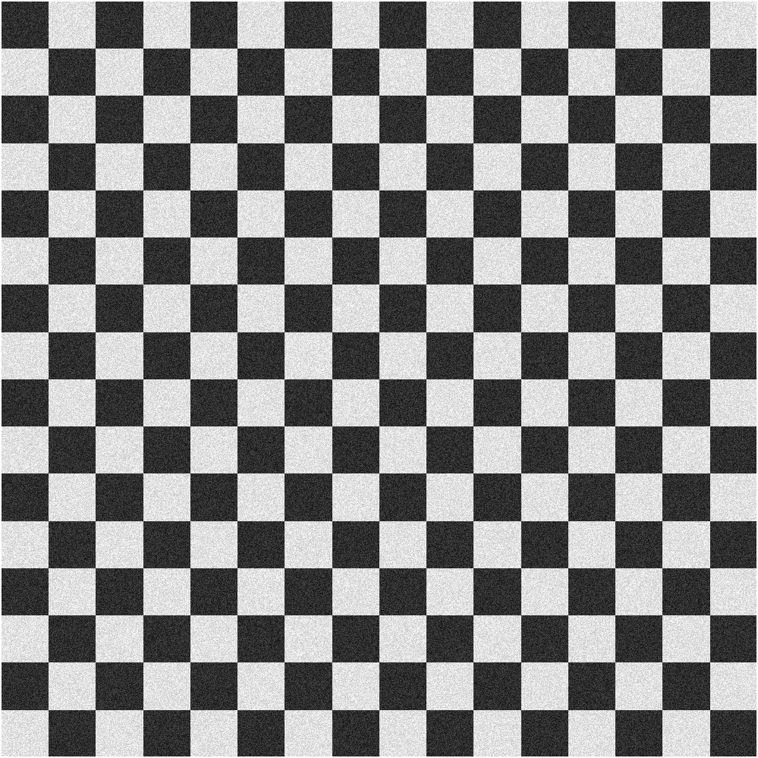

5 D) Histogram of recovered image:

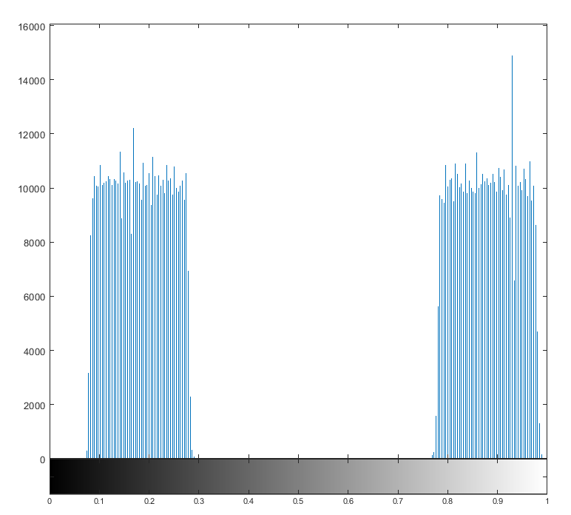

5 E) Segmented image:

5 F) What is the data type (class) for the segmented image?

We used doubles when we were working on the image, so the resulting segmented image is of data type double (size of about 8.4 MB).

5 G) How many bits (per pixel) is required to store this type of image?

it can be represented with just 1 bit per pixel (black or white) which gives us:

1023x1023x1 = 1 046 529 bits, which is about 0.13 MB.

6. RGB-images and indexing

6 A) Image of Swedish flag:

